Testimony of Polygamy by Early Saints

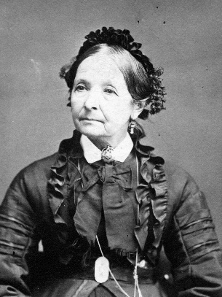
Eliza R. Snow, who was sealed to the Prophet Joseph Smith, recorded the details of the Prophet Joseph teaching the principle of plural marriage to her brother Lorenzo Snow. She noted the anguish and pain that the principle caused Joseph Smith and that he only moved forward in establishing the principle because of divine revelation:

Snow, Eliza R.
“The Prophet Joseph unbosomed his heart [to Lorenzo Snow], and described the trying mental ordeal he experienced in overcoming the repugnance of his feelings, the natural result of the force of education and social custom, relative to the introduction of plural marriage. He knew the voice of God—he knew the commandment of the Almighty to him was to go forward—to set the example, and establish Celestial plural marriage. He knew that he had not only his own prejudices and prepossessions to combat and to overcome, but those of the whole Christian world stared him in the face; but God, who is above all, had given the commandment, and He must be obeyed. Yet the Prophet hesitated and deferred from time to time, until an angel of God stood by him with a drawn sword, and told him that, unless he moved forward and established plural marriage, his Priesthood would be taken from him and he should be destroyed! This testimony he not only bore to my brother, but also to others—a testimony that cannot be gainsayed [contradicted]” (Biography and Family Record of Lorenzo Snow [1884], 69–70).

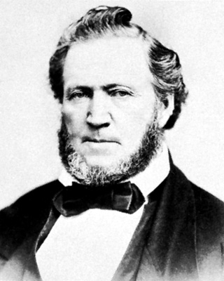
President Brigham Young explained:

Brigham Young
“If any man had asked me what was my choice when Joseph revealed that doctrine, provided that it would not diminish my glory, I would have said, ‘let me have but one wife.’ …

“… I was not desirous of shrinking from any duty nor of failing in the least to do as I was commanded, but it was the first time in my life that I had desired the grave, and I could hardly get over it for a long time. And when I saw a funeral I felt to envy the corpse its situation, and to regret that I was not in the coffin. …

“… But the saints who live their religion will be exalted, for they never will deny any revelation which the Lord has given or may give, though, when there is a doctrine coming to them which they cannot comprehend fully, they may be found saying, ‘the Lord sendeth this unto me, and I pray that he will save and preserve me from denying anything which proceedeth from him, and give me patience to wait until I can understand it for myself’” (in “Provo Conference,” Deseret News, Nov. 14, 1855, 282).

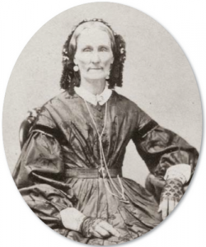
Vilate Kimball, President Heber C. Kimball’s first wife, received a testimony of plural marriage. Her daughter Helen recounted:

“‘My mother often told me that she could not doubt the plural order of marriage was of God, for the Lord had revealed it to her in answer to prayer.

“‘In Nauvoo, shortly after his return from England, my father, among others of his brethren, was taught the plural wife doctrine. …

“‘My father realized the situation fully, and the love and reverence he bore for the Prophet were so great that he would sooner have laid down his life than have betrayed him. This was one of the greatest tests of his faith he had ever experienced. …

“‘My mother [Vilate Kimball] had noticed a change in his manner and appearance, and when she inquired the cause, he tried to evade her questions. At last he promised he would tell her after a while, if she would only wait. This trouble so worked upon his mind that his anxious and haggard looks betrayed him daily and hourly, and finally his misery became so unbearable that it was impossible to control his feelings. He became sick in body, but his mental wretchedness was too great to allow of his retiring, and he would walk the floor till nearly morning, and sometimes the agony of his mind was so terrible that he would wring his hands and weep like a child, and beseech the Lord to be merciful and reveal to her this principle. …

“‘The anguish of their hearts was indescribable, and when she found it was useless to beseech him longer, she retired to her room and bowed before the Lord and poured out her soul in prayer to Him who hath said: “If any lack wisdom let him ask of God, who giveth to all men liberally and upbraideth not.” …

“‘Before her was illustrated the order of celestial marriage, in all its beauty and glory, together with the great exaltation and honor it would confer upon her in that immortal and celestial sphere, if she would accept it and stand in her place by her husband’s side. She also saw the woman he had taken to wife, and contemplated with joy the vast and boundless love and union which this order would bring about, as well as the increase of her husband’s kingdoms, and the power and glory extending throughout the eternities, worlds without end.

“‘With a countenance beaming with joy, for she was filled with the Spirit of God, she returned to my father, saying: “Heber, what you kept from me the Lord has shown me.” She told me she never saw so happy a man as father was when she described the vision and told him she was satisfied and knew it was from God.

“‘She covenanted to stand by him and honor the principle, which covenant she faithfully kept, and though her trials were often heavy and grevious to bear, she knew that father was also being tried, and her integrity was unflinching to the end. She gave my father many wives, and they always found in my mother a faithful friend’” (in Orson F. Whitney, Life of Heber C. Kimball [1967], 325–28).

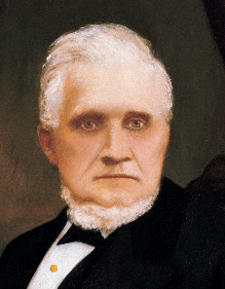
President John Taylor said of the time when the principle of plural marriage was introduced:

“I had always entertained strict ideas of virtue, and I felt as a married man that this was to me, outside of this principle, an appalling thing to do. … It was a thing calculated to stir up feelings from the innermost depths of the human soul. I had always entertained the strictest regard of chastity. … Hence, with the feelings I had entertained, nothing but a knowledge of God, and the revelations of God, and the truth of them, could have induced me to embrace such a principle as this” (in B. H. Roberts, The Life of John Taylor, Third President of the Church of Jesus Christ of Latter-day Saints [1963], 100).

